**CIS444 PROJECT PROPOSAL V4:**

**CSUSM STUDENT FAQ FORUM**

**Emily Arango, Kenneth Ha, Hunter Nitta-Hill, Nicholas Sotto, Kane Svelan**

Forum:

* Campus wide and separated into different majors
* Each major will have their own discussion forum
* Students may discuss studies, recommend classes, general discussions, concerns, any form of talking
* Blue and white school colors
* Undecided majors can ask major-related questions in forums
* Option to be anonymous
* Public discussion first then makes Direct message function if have time
* Potential risk: Lack of oversight can lead to unregulated comments
* Will predominantly be a student run website

Goal: General safe space discussion for Students

**Advantages over other existing sites:**

This forum page is intended to be an easy way for students to discuss school subjects and other topics. Examples of discussion would be receiving help from other students and reviewing a class or professors. Some of the assistance can be about certain assignments to help guide others to the correct answer or discuss topics. Discussion topics can be used to collaborate and help teach other students on subject matters that they may not understand fully. There will be an option to post and comment anonymously to encourage a collaborative environment. This site is made to be specific for the CSUSM student community. Because the site can jump to different majors and subjects, it makes it easy for students to learn more about other topics.

**Admin:**

This site will have an admin account that will be able to have permissions to delete posts based on regulations created by the team. They will have access to SQL statements such as “delete” to remove certain posts or comments. Each forum will be moderated by a single admin, who can also have access to other forums.

1. **Describe the real-life problem to be solved with a Web server.**

Currently, there exists no official CSUSM discussion forum that encompasses multiple topics for offered majors. This system would allow users to filter through forum threads to connect with other students with similar majors, career paths, ideas, and problems.

This would also allow accessibility for discussion and communication amongst students of different majors and would give students the convenience of asking for advice within one's own major or another.

1. **Identify all the potential users of such a website (ideally, you would have already interviewed some potential users at this stage).**

This system is primarily geared towards CSUSM students. More specifically, new/undeclared students who want to learn more about the majors/classes they are interested in. The system will also appeal to students who are not new and are trying to figure out which classes to enroll in.

We will use our own database to monitor and maintain the forum and webpages regularly.

1. **Include how many Web pages are potentially needed and what each page is exactly supposed to work, but not the actual implemented pages, and their wireframes.**

The system will have 6 main pages:

1. Sign-In Page
   1. Users will have to enter their username and password in the text boxes and then click sign in to access the forums.
   2. Checkbox option for “Remember Account” will allow users to have their username and password remembered upon signing in.
   3. If a user inputs an incorrect password or username, then it will give an error stating that the username or password is incorrect. This will tell the user that they need to reenter in their username/password.
   4. If the user does not remember their username or password, then they can click on the “Forgot username/password” to go to another page to reset their password.
   5. If the user does not have an account for the forum's website, then they can click on the “Sign Up” hyperlink to go to the Sign-Up Page
2. Sign-Up Page
   1. Users will enter their First and Last name into the text boxes provided.
   2. Users will then enter their CSUSM email address.
   3. Users will then enter their password into the first password input box.
   4. Users will reenter their password into the second password input box to verify that both the previous password and reentered password match.
   5. Once they have completed all textboxes then they will hit the “Sign Up” box to complete their sign-up process and will bring them back to the Sign-In page. If there are any errors, then it will tell the user to reenter any data into the textboxes.
3. Homepage / Major Catalog / Forums
   1. Displays all CSUSM majors and links to their forums
      1. Currently B.A and B.S degrees
   2. Includes links to respective academic department pages
   3. Navbar to view subject categories that goes into links to specific majors. This leads to the forum’s page.
   4. Section to view recent/stared/ your own posts. Will have similar functionality to forum page
4. Threads/Posts page(view)
   1. Allows users to view full threads/posts
   2. Reply/Comment section for replying to the original poster (OP)
5. Create Post
   1. Users must fill in a post title, post body, and at least one post tag to submit post which will also start a thread
   2. Multiple tags related to majors and classes may be submitted if separated by commas
   3. Upon submitting users will be redirected to the updated Forum webpage with their post included
   4. Upon clicking header links, users will be redirected to the corresponding page
6. Profile Page
   1. Users can change their username, password, and profile picture
   2. Users will be able to see a list of all the posts they have made
   3. Users can choose to post anonymously on the site (In Progress, currently not displayed in HTML)

*Function / Page priority scale (1: highest – 3: lowest)

|  |  |
| --- | --- |
| **Function / Page** | **Priority** |
| Sign-Up Page | 3 |
| Sign-In Page | 3 |
| Profile Page | 3 |
| Home Page | 1 |
| Major Catalog | 1 |
| Major Forum Board | 1 |
| View Post/Comment | 1 |
| Error Page | 1 |

1. **Indicate what users are expected to enter and receive for each page.**

* Sign-Up Page:
  + Users will create an account website access
    - Expected to enter the following: First Name, Last Name, CSUSM Email Address, Password, Re-Entered Password
  + When the account is created, they’ll be redirected to the Sign-In Page
* Sign-In Page:
  + Users will sign in with an account email and password and will be redirected to the Homepage.
* Homepage:
  + Users will see a list of all majors and their respective categories
  + Users will have access to their own forum posts
* List of Forums:
  + Discussion Forums organized in alphabetical order based on department
  + After selecting discussion forum, user is redirected to threads for that forum
  + Filter potentially can change the way that the discussion forums are organized
* Posts/Threads:
  + User will be able to see a list of posts/threads for a given forum, organized on last replied to date by default
  + Users can choose to make a new post/thread or view a preexisting post/thread and is then redirected to either depending on which is chosen
  + Users will be able to search specific topics through a search
  + User can filter threads based on tags
  + Filters can potentially change the way that the posts/threads are sorted
* Create a Post:
  + User will be able to create a new post which will start a thread
  + Users must add a title/topic, body text, and tags related to class/topic
  + A button will allow users to post once these conditions have been met
* View Thread:
  + User can see a list of all replies to a post/thread
* Reply to Thread:
  + User will be able to write a reply to a post/thread and post it through a button
* Profile Page:
  + User would be able to from different pages except from login/signup pages
  + User will be able to change their password
  + There will be a checkbox if the user wants to be anonymous on the site (In Progress, currently not displayed in HTML)
* Error Page:
  + Users would see this page if they tried to access something the doesn’t exist

1. **Illustrate how each potential user is going to interact with your Web site.**

First user will see the login page where they log in.

Then the user will be able to see the categories of majors.

Once the user clicks on the major(forum) they will be able to see the posts/threads which are created by the user about that major, and there will be tags on specific classes and topics.

Profile settings will be able to change profile pic, checkbox for anonymous or non-anonymous. Also include checkbox option to display major in profile. If the user decides to display their major, they can select their major from a drop-down list which will display the departments and subsequently select another drop-down sub-list for their major.

1. **Draw a diagram indicating the interactions among the Web pages, i.e., when a button or link is clicked on a page, which another page is to be loaded up to the user.**

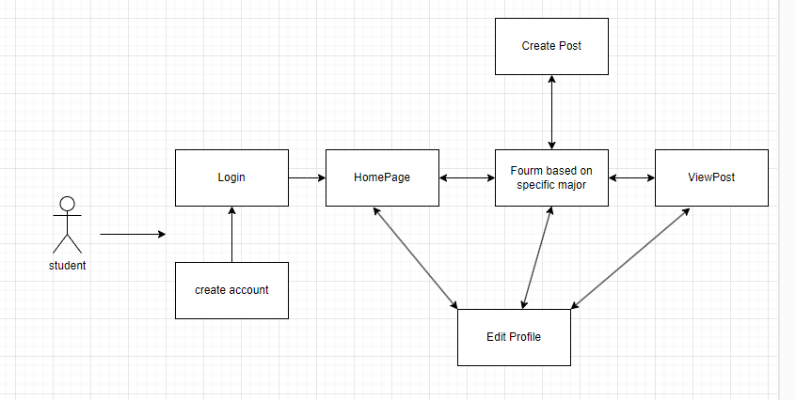

Newer one:

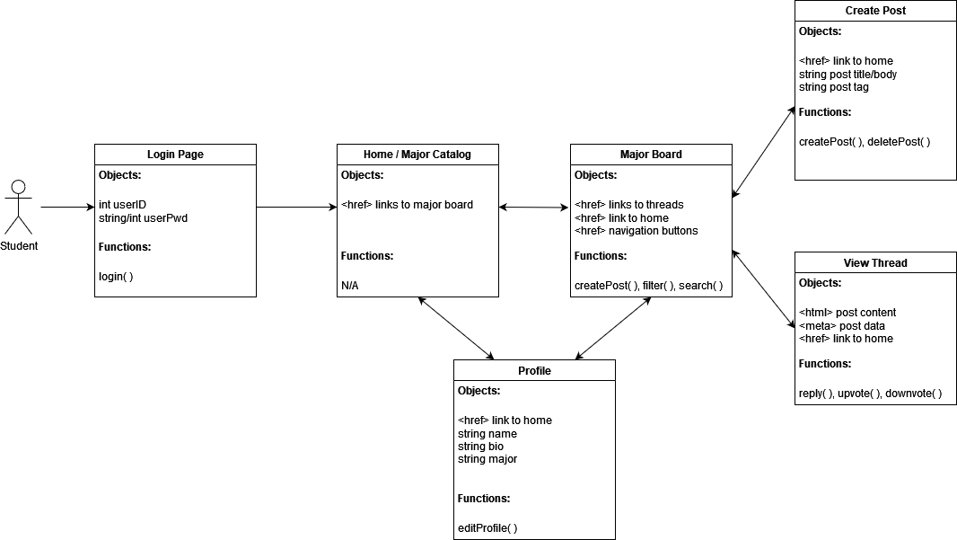

Sign In Page:

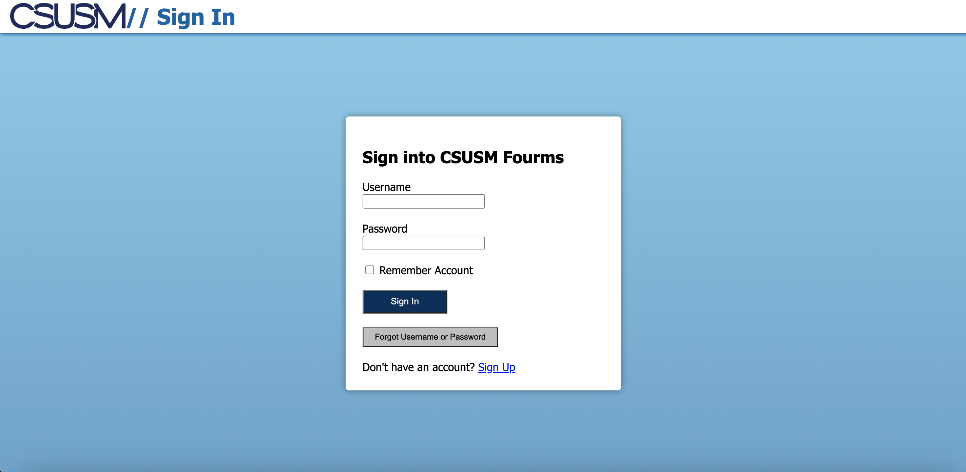

Sign Up Page:

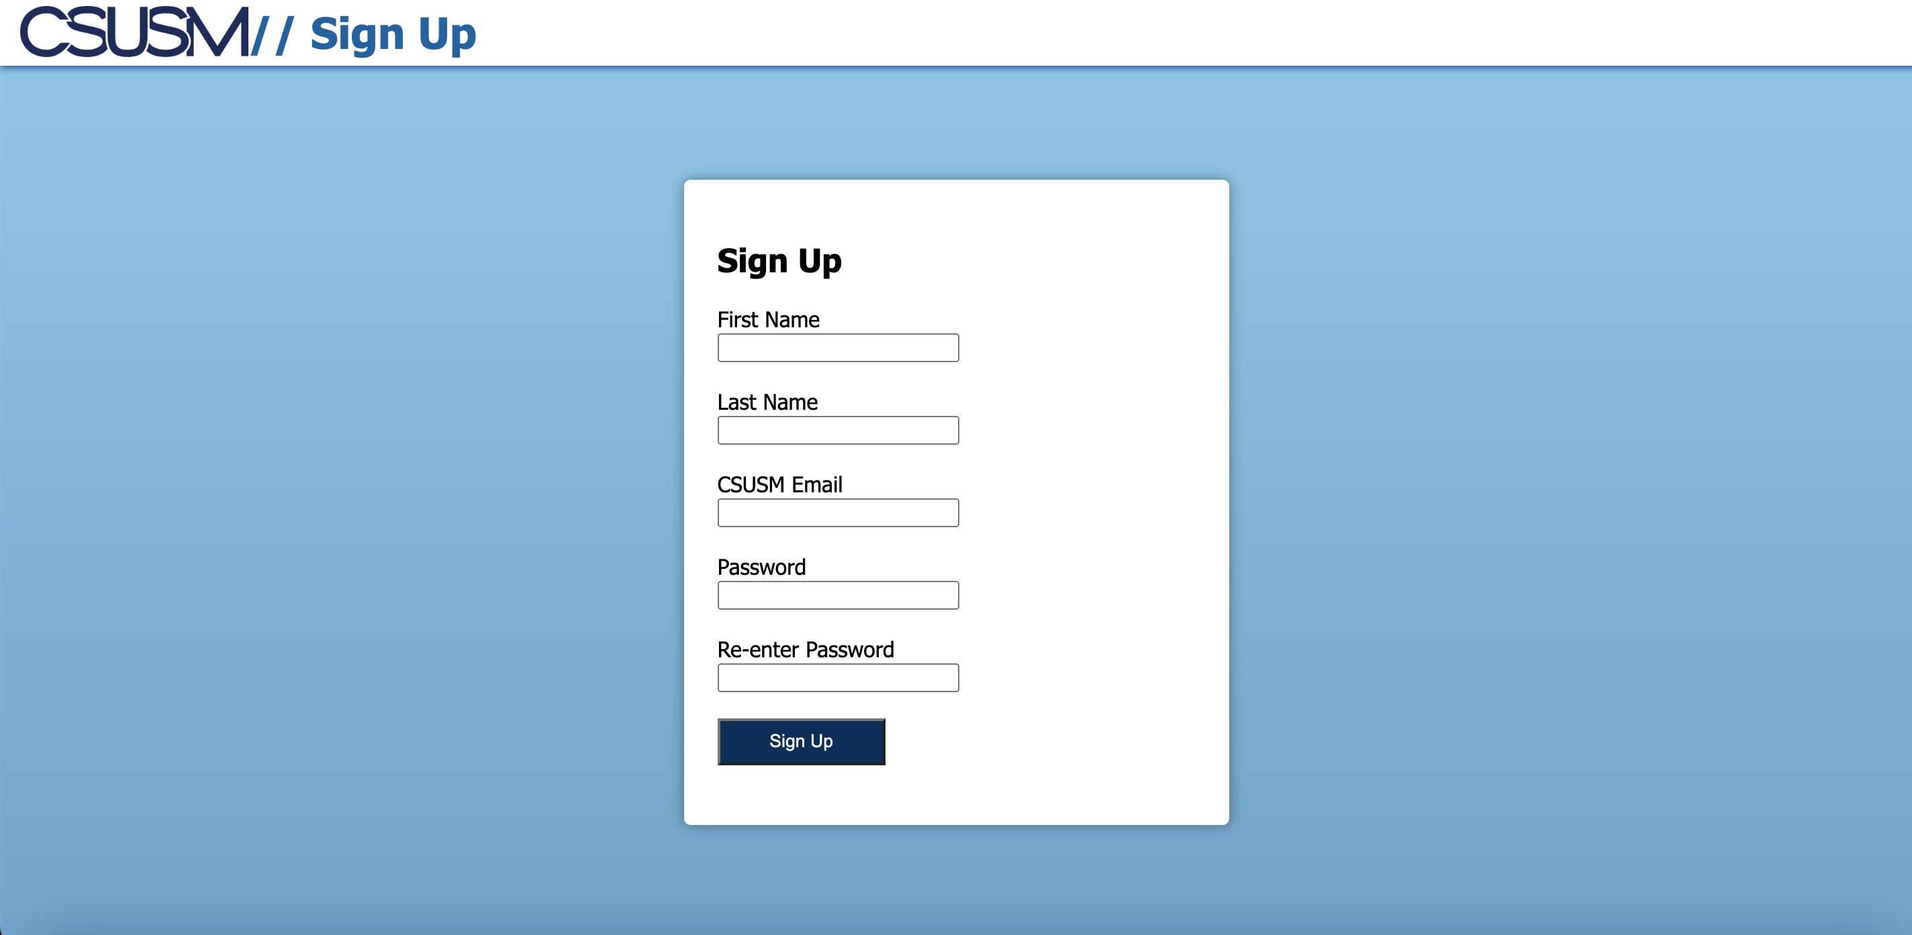

Homepage:

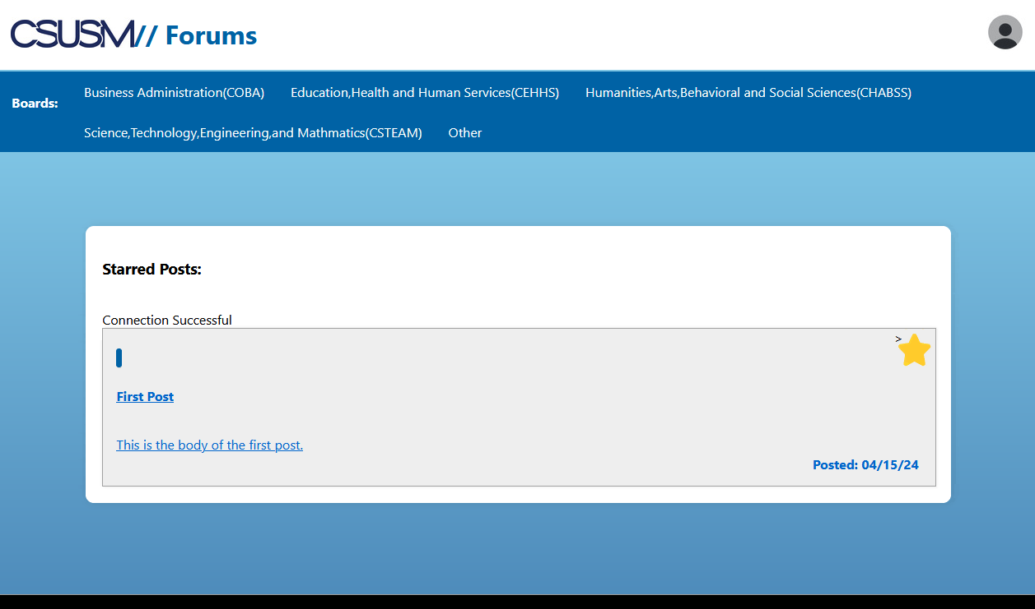

Create Post:

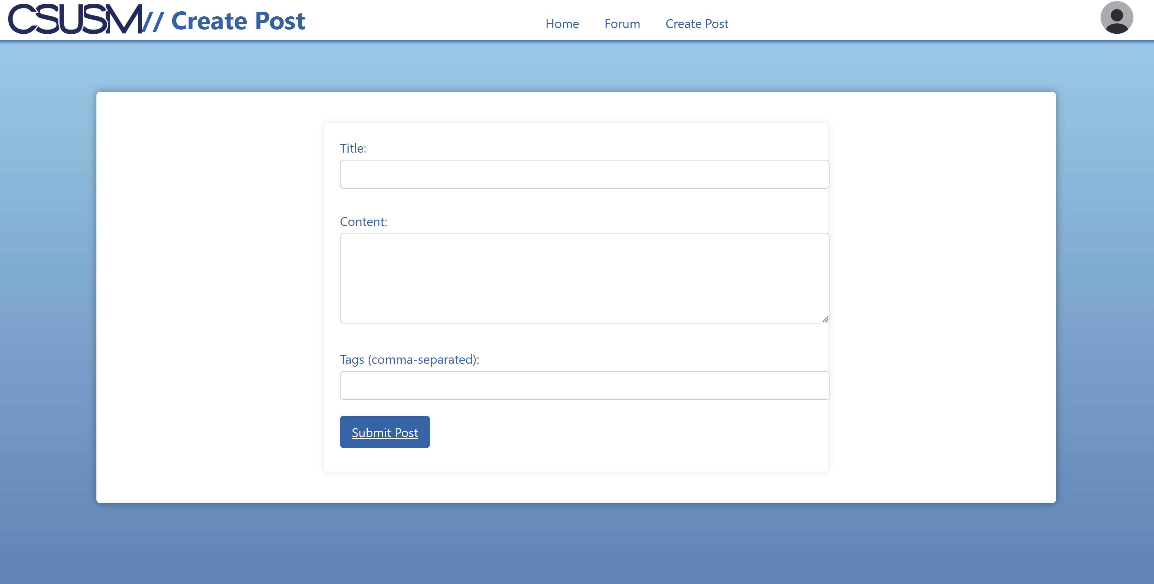

Forum View:

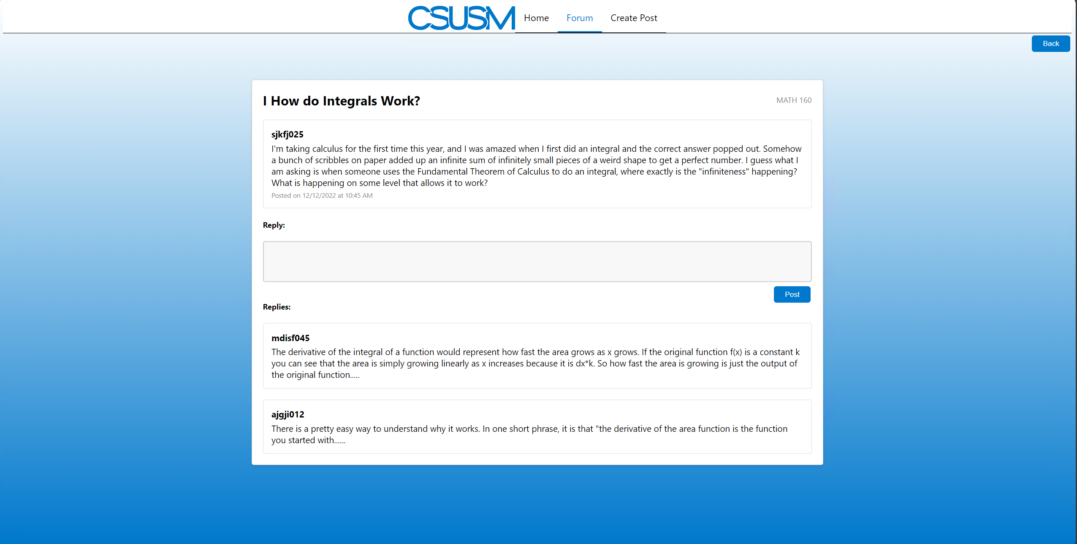

Forums Page:

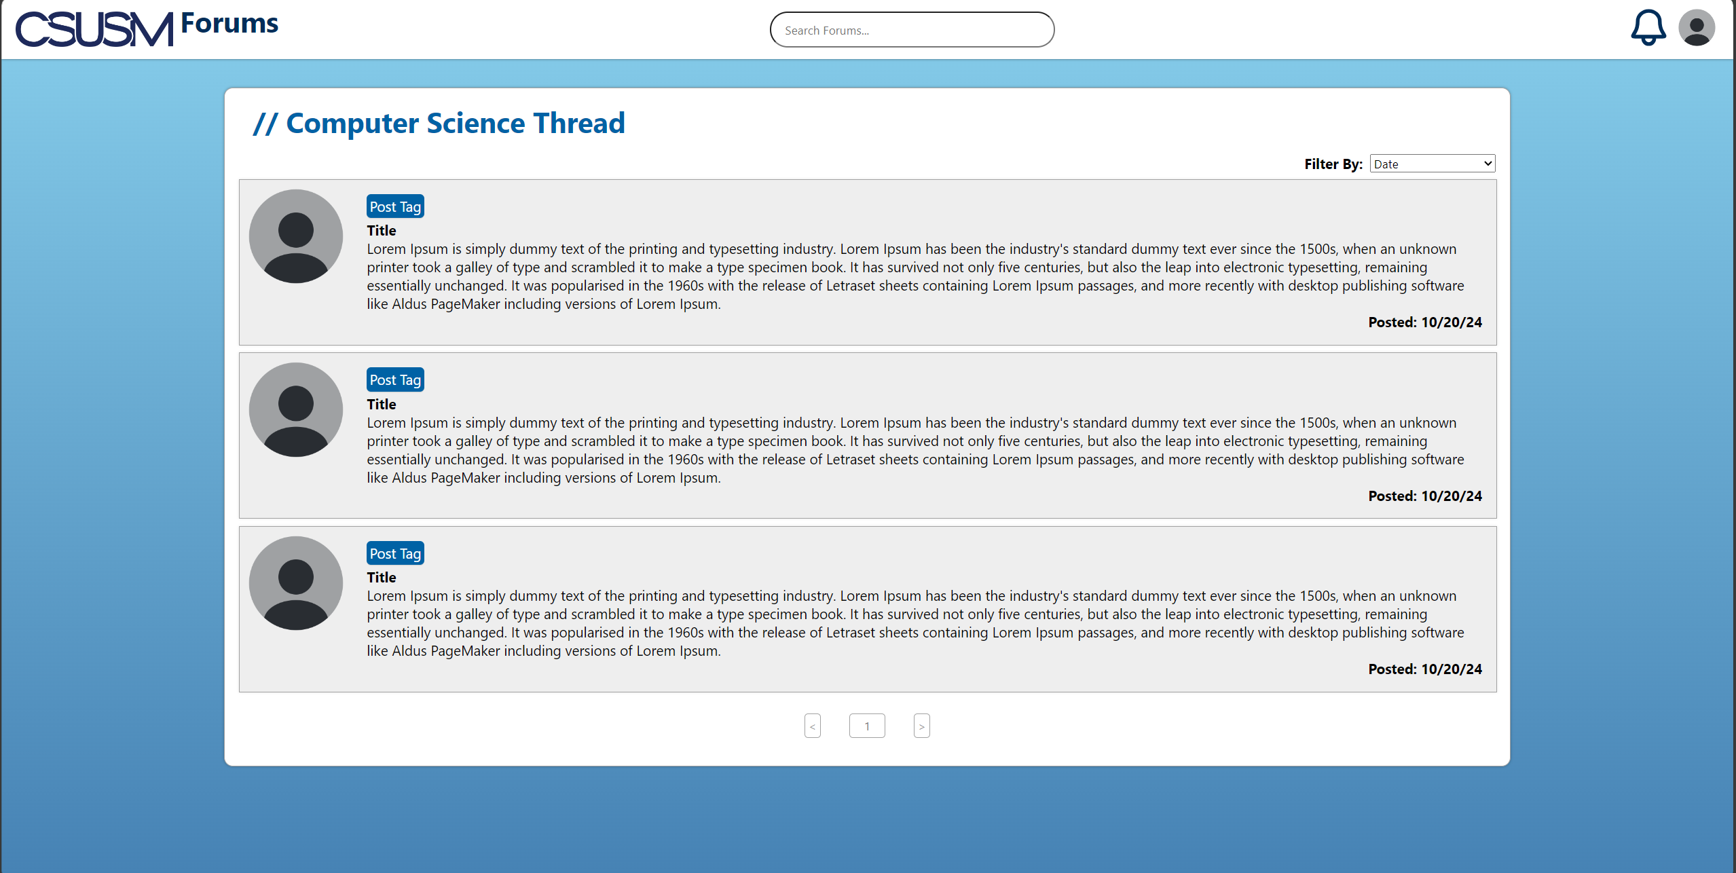

Profile Page:

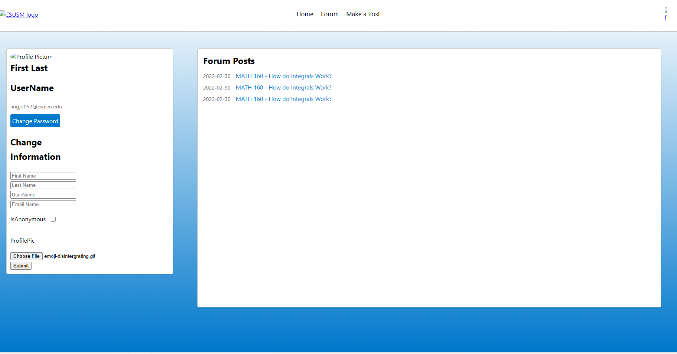

Error 404 Page:



**Meeting Minutes:**

Summary:

- Meet on Tuesdays and Thursdays 8pm for about 1.5 hours

- Mandatory meetings

- Topics: Assigning tasks and progress report. Evacuating and putting things together.

Date: April 23

Time: 8 PM – 10 PM

Minutes: 120 minutes

Participants: Kenneth, Emily, Kane, Hunter, Nicholas

Purpose: To assign tasks to each group member for Final part of project

Date: April 28

Time: 8 PM – 10 PM

Minutes: 90 – 180 minutes each meeting

Participants: Kenneth, Emily, Kane, Hunter, Nicholas

Progress report: Discussed dependences, risks, current progress

Date: April 30

Time: 8 PM – 10 PM

Minutes: 90 – 180 minutes each meeting

Participants: Kenneth, Emily, Kane, Hunter, Nicholas

Progress report: Discussed dependences, risks, current progress

Date: May 6

Time: 8 PM – 10 PM

Minutes: 90 – 180 minutes each meeting

Participants: Kenneth, Emily, Kane, Hunter, Nicholas

Progress report: Discussed dependences, risks, current progress

Date: May 8

Time: 9 PM – 12 PM

Minutes: 180 minutes

Participants: Kenneth, Emily, Kane, Hunter, Nicholas

Purpose: Meeting to fulfill deadline requirements and putting everything together.